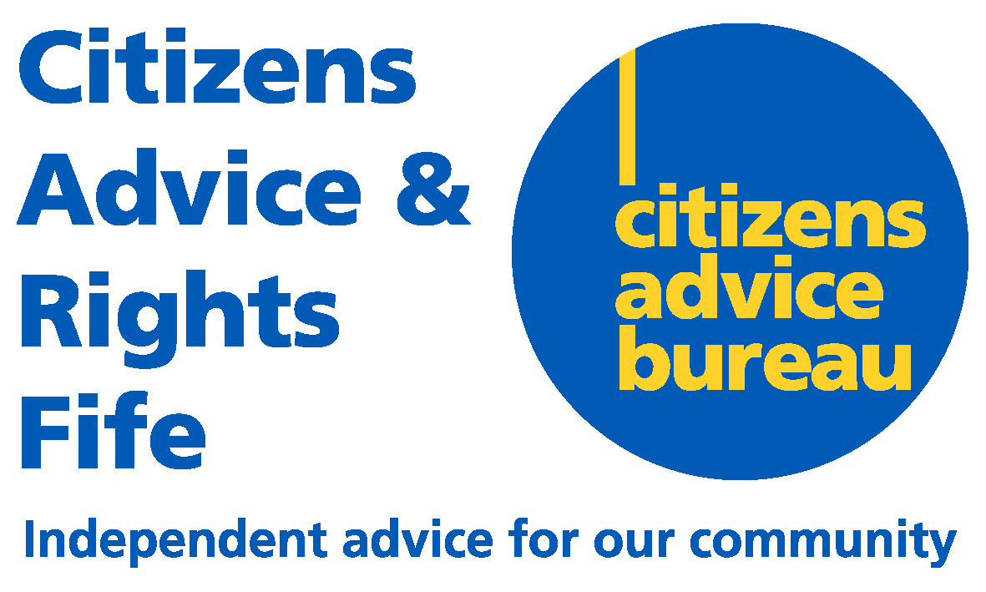 | Units 7 & 8  Craig Mitchell House  Flemington Road  Glenrothes  KY7 5QF

June 2016

Dear Applicant

MONEY ADVISER - PART TIME (17.5 HOURS) - FUNDED TO 31ST MARCH 2017

Thank you for enquiring about the above post.

I have enclosed the appropriate application pack, which includes –

- Job application form and guidance notes
- Job description, person specification
- Recruitment Monitoring Form

Completed application forms should be returned to -

Recruitment
Citizens Advice and Rights Fife
Units 7 & 8
Craig Mitchell House
Flemington Road
Glenrothes
KY7 5QF

Yours sincerely
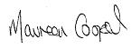

Maureen Cooper
Office Manager/PA to Chief Executive

Enc

