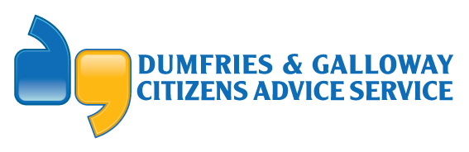
DAGCAS  SCQF Level 8 | Fundraising & Development Officer
Reporting To | Business Development Manager
Job Function /Location | HQ
Purpose of Job | The Fundraising & Development Officer will be responsible for:  - Implementing and updating our Funding & Income Generation Strategy to secure new income streams.  - Identifying relevant funding sources and applying for grants from statutory bodies and charitable trusts as appropriate.  - Establishing partnership working with like-minded organisations to allow extended delivery of projects.  - Exploring alternative fundraising methods and implementing these where appropriate.  - Supporting the Business Development Manager in the delivery of short-term projects.  - Providing back up for the smooth delivery of our financial services in the absence of the Finance Administrator and with the support of the Business Development Manager.  - Supporting the wider D&GCAS service delivery as per our corporate and operational objectives.
Competencies:
Scope of Work/ Degree of Autonomy | - Continue to develop an effective fundraising plan in line with the strategic direction set by the Board of Directors.  - Research the funding landscape, targeting and developing relationships with potential corporate sponsors or charitable organisations.  - Complete funding applications to statutory bodies and charitable trusts.  - Investigate, identify and attempt to secure alternative additional funding streams e.g. corporate sponsorship, legacies, online donations, new and imaginative fundraising activities e.g. events, campaigns etc.  - In conjunction with the Communications & Volunteer Development Manager, raise awareness of the work of the organisation to potential funders/sponsors, both locally and nationally.  - Use digital platforms to promote fundraising opportunities e.g. organise digital campaigns and promote opportunities to encourage individuals to donate or make provision for legacy donations to the company.  - Contribute to regular, ongoing evaluation and monitoring of fundraising activity and subsequent financial stability of the organisation.  - Collate details on staff absences, enrolments, leavers etc in the absence of the Finance Administrator.  - Carry out other duties as specified by the Manager and required by the needs of the post.
Processes | - To maintain accurate statistics for monitoring purposes.  - To adhere to company principles and uniform standards in case recording.  - Collate and report statistical information to senior management and the funders at agreed intervals.
Quality | - Ensure records are maintained which demonstrate compliance with training and competence requirements.  - Adhere to D&GCAS’ recognised good practice and standard processes and procedures to ensure governance and compliance at all times.  - Contribute to overall efficiency and quality of processes and procedures.  - Adhere to Citizens Advice Scotland membership standards.
Skills | - Exceptional written, oral and communication skills.  - IT Literate.  - Customer facing expertise.  - Organisational/planning skills.  - Person specification requirements are detailed in person specification document.
Knowledge | - Understand aims and principles of policies and procedures and contribute to development and revision of these policies and procedures.  - Have and maintain expertise in relevant legislation in this field of work.
Personal Development | - Identification of personal strengths and weakness, as well as identifying personal training needs.  - Attend in-house and external training courses as appropriate.  - Organise and attend team and staff meetings as required.

