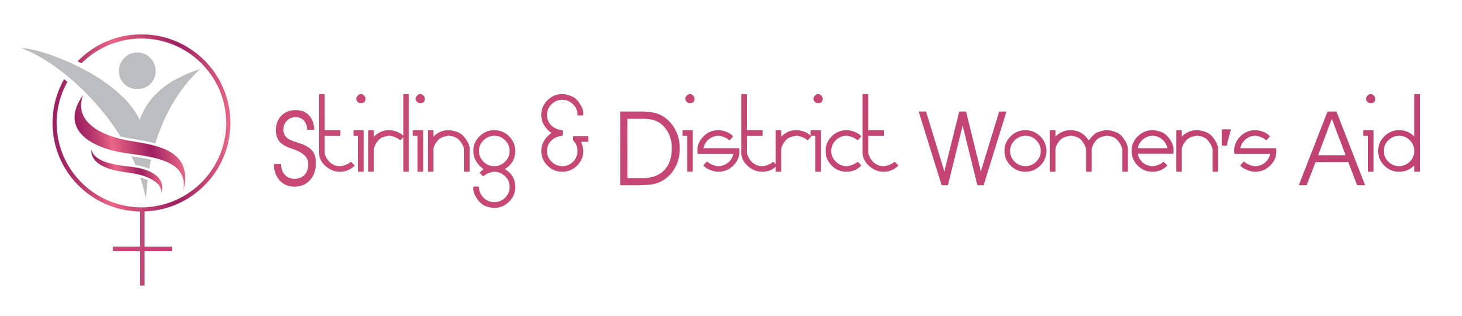

STIRLING CAB/WOMENS AID DOMESTIC ABUSE TRANSITIONS ADVICE PROJECT

Women and Children’s Solicitor

Employer: Stirling District Citizens Advice Bureau Ltd

Job Title: Women and Children’s Solicitor (Domestic Abuse Transitions Advice Project)

Responsible to: Steering Group of Domestic Abuse Transitions Advice (DATA) project

Salary £33,400 – £39,430 full time + 3% Contributory pension (6 months fixed term in the first instance with a possible 3 yr extension depending on funding application)

Only women need apply under Schedule 9, Part 1 of the Equality Act 2010

Main Purpose: To provide immediate legal advice, information and casework support on relevant legal issues (primarily protection, matrimonial conflict, separation and financial issues, children issues, interdicts, domestic assault), up to and including type 3 (representation), to women and children experiencing domestic abuse in the Stirling Local Authority Area, thus enabling them to make a safe, informed, empowered and sustained transition from the abusive situation to a secure and independent future.

The advice, information, casework support and representation offered will focus on access to legal advice to overcome the practical barriers caused by domestic abuse and giving holistic and sustained support to overcome these. DATA will be available at a range of easy access locations for the target group throughout Stirling Local Authority area, refuges, safe environments, homeless accommodation, CAB and Women’s Aid premises. Training on legal issues & 2nd tier legal consultancy support will also be provided to domestic abuse frontline workers across Forth Valley.

Responsibilities

- To offer immediate on the spot legal advice and casework support (up to and including type 3), to empower, enable and inform decision making to those seeking to move / or to those who have already fled an abusive relationship. The particular focus will be safety and legal advice to overcome the practical barriers – separation and financial issues, interdicts, children issues, matrimonial homes act, and legal issues that often inhibit forward motion.

- To support women and children experiencing domestic abuse in a variety of legal contexts – child protection, criminal prosecution , cases concerning small claims, summary cause, housing and the Debtors (Scotland) act 1987 and any other suitable areas as required, primarily financial and housing related matters

- To offer diagnostic legal advice and refer unrepresented clients to an appropriate agency to take on their cases as required.

- To offer representation to clients in court when deemed necessary

- To represent clients interests at case conferences and hearings.

- To liaise with the Sheriff Clerks Department of Stirling Sheriff Court and the Tribunal Service and to maintain and develop effective working relationships with other relevant stakeholders

- The provision of proactive and preventative Legal advice awareness sessions to interested parties to raise the profile of the legal issues and remedies surrounding domestic abuse in general and raise awareness of the legal processes to overcome the practical barriers that often impair transition

- To liaise with other agencies such as local authority departments, police, violence reduction unit, social work, homelessness teams other RSL’s, DWP and to work with these agencies to inform and develop a seamless service for DATA clients

- To work with the aforementioned agencies in the pursuit of a preventative approach to problems that lead to legislative action

- To develop the voluntary front line capacity of the CAB + Women’s Aid in Stirling Local Authority Area to facilitate informed, enabled and empowered decision making in relation to the process of sustained transition from the abusive relationship

- The provision of a second tier legal consultancy service to frontline agencies engaged in the process of transition for DATA project across Forth Valley.

- The provision of legal training to frontline agencies engaged in the process of transition for DATA project across Forth Valley.

- To develop and maintain referral procedures with the Sheriff Court and other agencies

- To fully participate in the monitoring of the service and to keep adequate records of advice or representation offered as well as all referrals made to and from DATA project

- To assist the provision of full project reports and analysis to the DATA steering group

- To be proactive in promoting the service, raising public awareness of the assistance available and encouraging people to seek assistance from DATA project

- To keep up-to-date with relevant legislative changes

- To undertake such other duties as may reasonably be requested

Accountability

- Provide written reports to monthly supervision sessions with Steering Group of Domestic Abuse Transitions Advice (DATA) project

- Attend annual appraisal

- Attend Annual General Meeting and quarterly reviews of project ( along with DATA caseworker) with Steering Group of Domestic Abuse Transitions Advice (DATA) project



