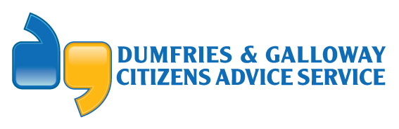 | 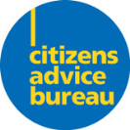
DAGCAS  SCQF Level 9 | Business Development Co-ordinator – Fundraising & Projects
Reporting To | Business Development Manager
Job Function /Location | HQ
Purpose of Job | The Business Development Co-ordinator - Fundraising & Projects will be responsible for:  - assisting in the ongoing development of our Funding & Income Generation Strategy to secure new income streams.  - Support the Business Development Manager in all aspect of the role including but not limited to buildings maintenance management, health and safety management, and financial management.  - the implementation, development and successful delivery of short term projects.  - assisting in the recruitment of staff.  - supporting and line managing staff in short term projects.  - Support the wider DAGCAS service delivery as per our corporate and operational objectives.
Competencies:
Scope of Work/ Degree of Autonomy | - Develop an effective fundraising plan in line with the strategic direction set by the Board of Directors.  - Research the funding landscape, targeting and developing relationships with potential corporate sponsors or charitable organisations.  - Complete funding applications to statutory bodies and charitable trusts.  - Investigate, identify and attempt to secure alternative additional funding streams e.g. corporate sponsorship, legacies, online donations, new and imaginative fundraising activities e.g. events, campaigns etc.  - In conjunction with the Communications & Volunteer Development Manager, raise awareness of the work of the organisation to potential funders/sponsors, both locally and nationally.  - Use digital platforms to promote fundraising opportunities e.g. organise digital campaigns and promote opportunities to encourage individuals to donate or make provision for legacy donations to the company.  - Contribute to regular, ongoing evaluation and monitoring of fundraising activity and subsequent financial growth in the organisation.  - Line manage and provide ongoing support for staff.  - Undertake case checks in line with company procedures.  - Work in conjunction with the Senior Management Team to ensure the requirements of the Funding Agreements are met.  - Develop links and work collaboratively with a wide range of local and national statutory and non-statutory agencies to ensure the provision of high-quality services.  - Carry out other duties as specified by the Manager and required by the needs of the post.
Processes | - To maintain accurate statistics for monitoring purposes.  - To adhere to company principles and uniform standards in case recording.  - Collate and report statistical information to senior management and the funders at agreed intervals.
Quality | - Ensure records are maintained which demonstrate compliance with training and competence requirements.  - Adhere to DAGCAS’ recognised good practice and standard processes and procedures to ensure governance and compliance at all times.  - Contribute to overall efficiency and quality of processes and procedures.
Skills | - IT Literate.  - Customer facing expertise.  - Excellent written, oral and communication skills.  - Organisational/planning skills.  - Person specification requirements are detailed in person specification document.
Knowledge | - Understand aims and principles of policies and procedures and contribute to development and revision of these policies and procedures.  - Have and maintain expertise in relevant legislation in this field of work.
Personal Development | - Identification of personal strengths and weakness, as well as identifying personal training needs.  - Attend in-house and external training courses as appropriate.  - Organise and attend team and staff meetings as required.

