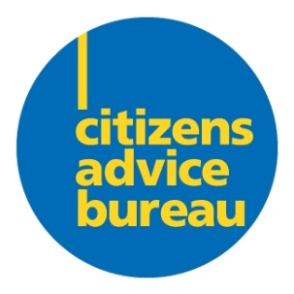
Parkhead Citizens Advice BureaU
Post 1 : Barlinnie & Community Link Training Officer
Post 2 : Barlinnie Welfare Rights and Money Adviser

Parkhead CAB is seeking applications for suitably experienced and enthusiastic individuals to join our staff team. This new exciting project funded by the National Lottery Community Fund will extend our work in Barlinnie prison with both advice services and our new project to encourage peer to peer advice between prisoners and engagement with community volunteering on release.

TRAINING OFFICER
£ 28,268 (plus pension, NI etc)
35 hours/week

This is an exciting opportunity for an experienced trainer and mentor to join Parkhead Citizens Advice Bureau. The post holder will work between Barlinnie prison and Parkhead CAB. The main aim of the post is to lead a programme of personal and social development including life skills workshops and to provide support and training to enable participants to be able to deliver advice and information to their peers. The ultimate aim will be to also give the advisers the confidence and knowledge to take the skills they have learnt and gain employment and or volunteering opportunities on release. The Training Officer will be responsible for forging links in the community for relevant future placements.
The post holder should have a knowledge of advice and information ideally in a CAB or similar advice giving setting.

WELFARE RIGTHS AND MONEY ADVISER
£ 25,576 (plus pension, NI etc)

This is an exciting opportunity for someone who wants a job that makes a real difference. The post holder will be providing advice and representation to clients and working with colleagues to also support highly trained volunteers to deliver welfare rights and money advice to our clients. You should have advice delivery experience and thrive on a challenge and assisting your clients to tackle their issues and support them to move forward and plan long-term solutions rather than a quick fix. We believe strongly in delivering a quality advice service in line with the Scottish National Standards.

Parkhead CAB offers a unique opportunity to make a difference in a supported environment where your colleagues are like-minded people. We also offer on-going training and development opportunities.

Closing date for applications is Monday 16th May 2022
Interviews by arrangement likely to be via zoom.
Please email info@parkheadcab.org.uk to request an application pack or download from the advert.

Parkhead CAB strives to be an equal opportunities employer and welcomes applications from all sections of the community. Please note this post will be subject to a disclosure check.

