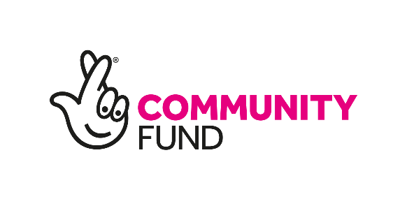

Advocacy Worker

Stronger Start

Funded by the National Lottery

Job title: Advocacy Worker
Organisation: Renfrewshire Citizens Advice Bureau
Project: Stronger Start
Location: Hybrid (with travel throughout Renfrewshire, West Dunbartonshire & Inverclyde
Salary: £24,861.20 (per annum – pro rata)
Position type: Part-time (up to 28 hours a week) (job sharing considered)
Fixed term: 1-year contract (January 2024 – January 2025)
Interviews: Anticipated W/C 13th November

About us: Renfrewshire Citizens Advice Bureau is a local, independent charity that provides free, impartial, and confidential advice.
Job Description: As an Advocacy Worker for the Stronger Start project, you will play a critical role in supporting pregnant women and new mothers, helping them address their concerns, understand and execute their action plans, and offer empathetic listening. A PVG is essential for this position. Your responsibilities will include:

Key Responsibilities:
- Dedicated Advocacy: Provide dedicated advocacy and support services to women participating in the Stronger Start Project, focusing on addressing key areas of concern and assisting them in understanding and implementing their action plans.

- Empathetic listening: Offer empathetic listening to clients, creating a safe and supportive environment for them to share their challenges and goals.

- Collaboration: Facilitate communication and cooperation with the Advice Worker and social workers as needed, ensuring a coordinated approach to client support.

- Client Relationships: Develop and maintain strong relationships with clients, fostering trust and encouraging self-empowerment, helping them to achieve their personal and project-related objectives.

- Assessment of Evolving Needs: Assess the evolving needs of clients, recognising that their circumstances may change between appointments with the Advice Worker. Work closely with the Advice Worker to ensure that clients’ support needs are met effectively.

- Referral Coordination: Ensure the coordination of referrals for ongoing issues by partnering with local agencies, making sure that clients have access to the resources and services they require.

Person specification:
- Previous experience in advocacy, counselling, or a related field is highly desirable.

- Strong understanding of issues related to pregnancy, motherhood, and social issues.

- Exceptional interpersonal and communication skills.

- Empathetic, patient, and dedicated to fostering client self-empowerment.

- Ability to work well in a team and independently

- Strong organisational and time-management skills

- Commitment to confidentiality and ethical standards.

- Ability to adapt to evolving clients' needs and effectively coordinate support.

- Knowledge of local resources and services available to pregnant women and new mothers.

How to apply:
If you are passionate about making a positive impact in the lives of pregnant women and new mothers, and you meet the qualifications and qualities outlined in our person specification, we invite you to apply. Please complete the attached application form and send it to manager@paisleycab.casonline.org.uk by the 6th of November 2023.

