scab.org.uk
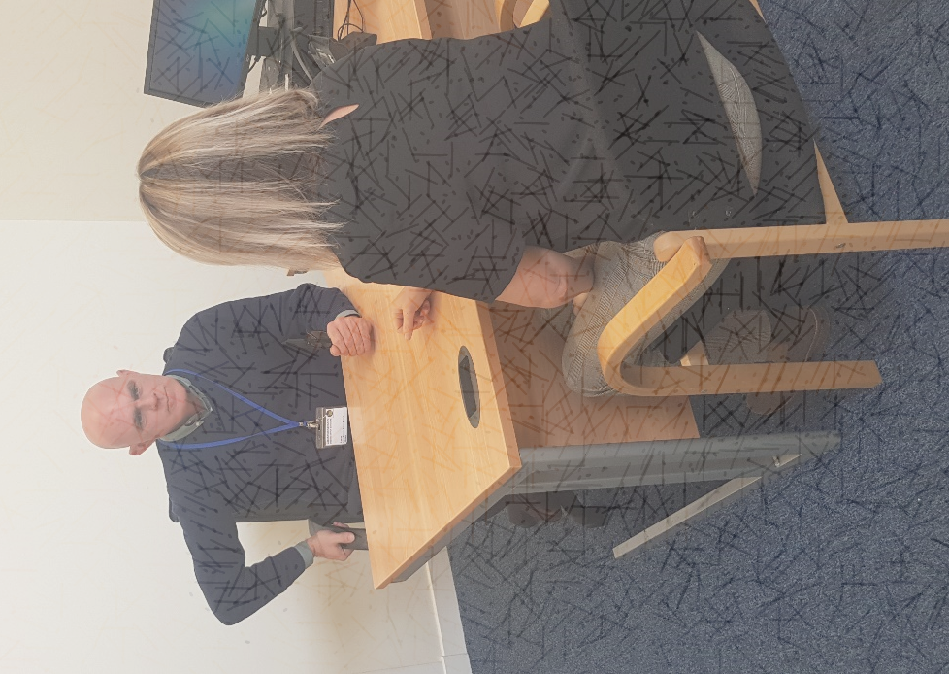

Working with us :
Housing Advice & Mediation Service (HAMES)

Contents

A note from our Managing Director, Jonny Miller

About Our Bureau

About the Role

Job description

Person Specification

How to Apply

A note from our Bureau Manager
“Thank you for your interest in joining the Clackmannanshire Citizens Advice Bureau Team. Our employees and Volunteers play a critical role in helping the people of Clackmannanshire get the advice, help and support they need.

We hope this pack will give you the information you need to decide if a role with us is right for you. We rely on each member of the team to bring their own unique skills, experience, views and commitment to our goals – it’s that combination which makes our organisation what it is.

The Clackmannanshire Citizens Advice Bureau gives much-needed advice and information to people from all walks of life, on a huge range of issues. We give advice – face to face, online and by telephone. The services we provide make a difference in communities across Clackmannanshire, ensuring people are aware of their rights and responsibilities. We look forward to hearing from you if you decide to apply and to learning more about what you can bring to this role, and to the team.”

Jonny Miller, Managing Director
Clackmannanshire Citizens Advice Bureau
Housing Advice & Mediation Service Job Pack, Clackmannanshire Citizens Advice Bureau

About Our Bureau
The Clackmannanshire Citizens Advice Bureau Service was established in 1967 and funded by Clackmannanshire Council, with a service level agreement in place. The aim was to provide free, confidential, impartial and independent advice, since then we have grown significantly. We now have a team of around 25 paid and 45 volunteer staff and provide a range of services in addition to our general advice service through 16 additional projects, (Find out more: www.clackscab.org.uk)

We are a volunteer led organisation, all volunteers undergo a comprehensive training course lasting at least 6 months training before working as advisers.

We have a strong volunteer Board of Directors who provide governance support to the Managing Director and staff/ volunteer team. We are a registered charity and company limited by Guarantee

We are affiliated to Citizens Advice Scotland which has opened many doors for us, giving us access to training, funding and IT support to name a few. Each year demand for our services has increased. People of Clackmannanshire can now, as well as receiving Generalist Advice, receive advice given by our specialists on Patient Advice, Help to Claim (Universal Credit), Multichannel and Face to Face, Welfare Rights, including Money Advice, Welfare Reform, Criminal Justice, Housing Debt, Financial Health Checks, Energy and Debt. In addition we provide a very successful Outreach Mental Health Financial Education Programme and a limited number of home visits by appointment. We also provide an HMP Glenochil pre-release training programme. We are accredited to Type III in Scottish National Standards for Advice providers by the Scottish Legal Aid Board (most recent audit December 2018), this is the highest accreditation available in the areas of Housing, Welfare Benefits and Money Advice. We are a progressive organisation with a strong focus on our social policy work helping us to influence change.

We rely on local Authority and External trust funding and donations to fund all of our service. All Citizens Advice Bureaux are independent and have their own Board of Directors and sources of income.

From April 2018 to March 2019 we helped over 3,495 people on 12,090 occasions and assisted with 19,311 different issues. We enabled clients to access £2.5 Million Client Financial Gain in the form of successful benefit applications and appeals, debt write offs, grant applications, employment issues, and securing charitable support, energy efficiency, housing and much more. For every £1 of our core funding that we received from Clackmannanshire Council in 2018/19 we returned £21.37 back into the local communities’ pockets. In addition to our core funding from Clackmannanshire Council Securing other sources of funding is more important now than ever to meet the growing complex demands for advice.

Every day is different in our office and we hope that you would find the advertised role to be both challenging and rewarding.

About the Role
Job Title: Housing Advice & Mediation Service (HAMES) Adviser
Responsible to: Volunteer & Project Co-ordinator
Hours: 17.5 Hours per week (Fixed term for two years until 30th June 2021)
Location: Based at Clackmannanshire Citizens Advice Bureau
Salary: £20,800 - £25,550 pro rata (depending on experience)
Closing Date: Friday 24th May 2019 at 12 Noon (Interview date: 6th June 2019)

The HAMES Adviser will actively prevent homelessness and assist private tenants to remain in their current property through income maximisation, debt advice and assistance, representation in court and tribunals, where required. Will provide budgeting and money management skills to empower private tenants to manage their budget effectively. They will also be responsible for building good working relationships with Private landlords across the region.

Job description
Key responsibilities
To conduct face-to-face, telephone and email interviews, using sensitive listening and questioning skills to allow clients to explain their problem(s) and empower them to set their own priorities.

- To explore clients’ circumstances, support their needs and channel preferences considering language barriers, accessibility needs.
- Assist new private tenants by making them aware or their rights and responsibilities of being a tenant.
- Provide benefit checks to ensure that private tenants have their income maximised including budgeting, energy advice and debt.
- Inform new tenants of any financial help they will be entitled to, assisting with on-line Scottish Welfare Applications to assist with rent deposits and furniture
- Provide assistance to private tenants facing eviction through negotiation and mediation with the landlord
- If required provide representation at first tier tribunal or courts
- Work with private landlords/Tenants and Residents Federation to set up a Private Landlords Forum to share best practice
- Provide workshops to private landlords in Clackmannanshire to make them aware of their legal obligations towards their tenants.
- Put in place a direct referral system allowing us to work with both the tenants and landlords to achieve a mutually agreeable solution.
- Work closely with statutory and third sector agencies to publicise the project
- Publicise the project through social media e.g. Face book, Twitter and website and through distribution of flyers, leaflets
- Design of a private tenants guide for distribution to private tenants in Clackmannanshire.
- Provide required reports in conjunction with Project Coordinator to Safe Deposit Scotland trust.
- To record, update and maintain information on our case management system for the purpose of continuity of casework, information retrieval, statistical monitoring and report preparation

The above job description is not exhaustive and is clarified to include broad duties
Inherent in the post as reasonably requested by the bureau Managing Director.

Person Specification
Essential
- Educated to degree level or have equivalent relevant experience
- Minimum 3 years work experience in office systems and procedures.
- Experience in housing related advice to Type III Scottish National Standard
- Good awareness and understanding of how rights and advice issues impact on the local communities and understand the issues involved in interviewing clients.
- Experience in carrying a complex caseload.
- Working knowledge of court/ tribunal procedures in relation to evictions and housing related matters.
- An excellent working Knowledge of Welfare benefits and better off calculations
- Effective oral and writing skills including through IT with particular emphasis on negotiating, representing and preparing reviews, reports and correspondence.
- Ability to prioritise own work, meet deadlines and manage caseload and an ability to work under pressure when immediate action is required.
- An innovator who likes the challenge of developing and implementing new approaches
- Ability to give and receive feedback objectively and sensitively and a willingness to challenge constructively.
- Excellent team player
- Demonstrate understanding of social trends and their implications for clients and service provision
- Willing to be flexible and adaptable in meeting the needs of the service

Desirable
- Experience of working in the advice sector
- Experience of working in the housing sector.
- Ability to interpret complex legal issues and find solutions
- Experience in organising training programs
- Experience of undertaking research and/or consultation
- Experience of CASTLE case recording system
- Experience in representation in both debt and benefit related issues
- Awareness of the social needs of local communities and services provided by the voluntary sector
- Proven ability to work within a community development or volunteer setting.
- Experience of partnership working in the voluntary and statutory sectors
- An in depth knowledge of local Private Rented Sector housing legislation
- A knowledge of homelessness procedures
- Understanding of and commitment to the aims and principles of the CAB service and its equal opportunities policies

How to Apply
To apply for this role, please send completed copies of the Application Form, along with
a covering letter to: eleanor.penman@clackscab.casonline.org.uk

We will shortlist for interview only based on the information provided within in the application form which demonstrate how you meet the requirements of the post, please refer directly to the job description and person specification.

Equality & diversity monitoring: To help us monitor equality and diversity statistics please return the Equality & Diversity Monitoring Form separate from your other application documents by emailing it to: jonny.miller@clackscab.casonline.org.uk

Clackmannanshire Citizens Advice Bureau
Glebe Hall
Burgh Mews
Alloa
FK10 1HS
Tel: 01259 219404
Email:bureau@clackscab.casoline.org.uk

Scottish charity SC001839 and company limited by guarantee SC493971

